1. Rank the world’s top five religions by number of followers, starting with “1” for the largest:
A. Buddhism ( )
B. Islam ( )
C. Christianity ( )
D. Hinduism ( )
E. Confucianism-Taoism ( )

2. The world’s largest Muslim population can be found in:
A. Middle East
B. Southeast Asia
C. Africa
D. South Asia
E. Western Europe

3. Rank the following countries by the percentage of Buddhists in the population, starting with “1” for highest percentage:
A. Myanmar ( )
B. China ( )
C. Thailand ( )
D. Vietnam ( )
E. Japan ( )

4. Rank the following countries by the percentage of Muslims in the population, starting with “1” for highest percentage:
A. Syria ( )
B. Saudi Arabia ( )
C. Iran ( )
D. Malaysia ( )
E. Indonesia ( )

5. There are different denominations in Islam. Name as many as you know:
A.
B.
C.
D.

6. There are different denominations in Christianity. Name as many as you know:
A.
B.
C.
D.

7. There are many different sects in Buddhism. Name as many as you know:
A.
B.
C.
D.

8. The holy book of Christians is:
A. Qu'ran or Koran
B. Bible
C. Vedas
D. Torah

9. The sacred texts of the Hindus include:
A. The Torah and the Hebrew Bible
B. The Qu'ran and teachings of Abraham

C. The Vedas, Mahabharata and the Upanishads

10. The holy book of Buddhism is the:
A. Sutra
B. Tripitaka
C. Vedas
D. Guru Granth Sahib

11. The Torah is the sacred text of:
A. Judaism
B. Christianity
C. Islam
D. None of the above

12. Which is NOT one of the Five Pillars of Faith in Islam?
A. Give to charity
B. Pray five times a day
C. Travel to Mecca at least once in your lifetime
D. Become a missionary in a foreign land
E. There is no God but God and Muhammad is the Messenger of God.

13. Judaism, Christianity, and Islam all:
A. Believe in many divine Gods
B. Worship only one God
C. Follow the teachings of the Qu'ran
D. Believe Jesus was the son of God

14. The belief that the soul never dies but is continually reborn is associated with:
A. Islam
B. Christianity
C. Judaism
D. Hinduism and Buddhism

15. Following the Eightfold Path and the Four Noble Truths to achieve enlightenment is associated with:
A. Buddhism
B. Hinduism
C. Islam
D. Christianity

16. This religion can be divided into Catholic, Protestant, and Eastern
Orthodox
A. Judaism
B. Christianity
C. Islam
D. Buddhism

17. Diwali, the festival of Lights, is celebrated by followers of:

A. Christianity
B. Judaism
C. Hinduism
D. Islam
E. Buddhism

18. Wesak or Vesak Day is celebrated by followers of:

A. Christianity
B. Judaism
C. Hinduism
D. Islam
E. Buddhism

19. Eid al-Fitr is celebrated by followers of:

A. Christianity
B. Judaism
C. Hinduism
D. Islam
E. Buddhism

20. The following symbol represents which religion?

A. Christianity
B. Hinduism
C. Islam
D. Judaism

21. The Star of David is associated with:
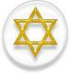
A. Judaism
B. Christianity
C. Islam
D. Hinduism

22. The "Om" symbol is associated with

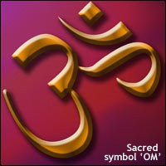
A. Buddhism B. Hinduism
C. Islam
D. Judaism

23. There are thousands of gods in this religion. What religion is this?
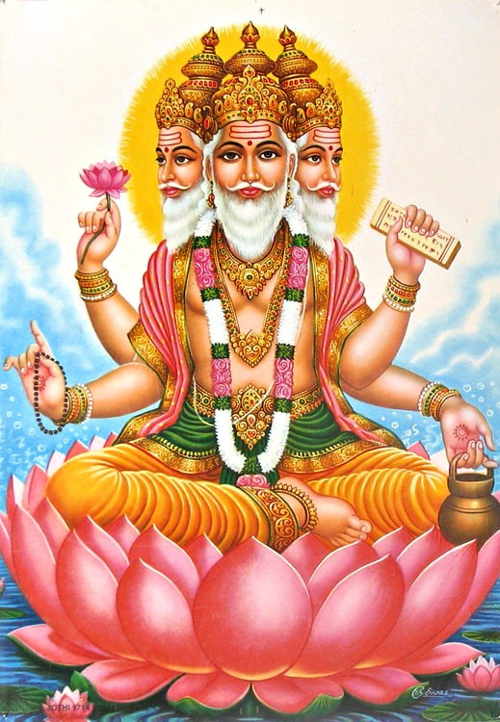
A. Judaism
B. Hinduism
C. Islam
D. Buddhism

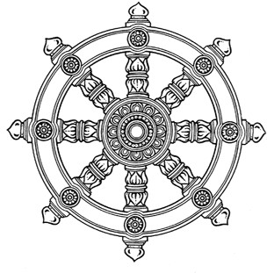
24. The cross and the wheel of Dharma are symbols of:

A. Hinduism and Islam
B. Christianity and Islam
C. Christianity and Buddhism
D. Judaism and Hinduism

25. The predominant religion in the Middle East (located between Africa and Asia), including countries such as Saudi Arabia and Iran is

A. Islam--Sunni
B. Christianity--Protestant C. Islam -- Shia
D. Islam - Wahabism

26. The predominant religion in South America is:

A. Christianity--Roman Catholic
B. Islam--Sunni
C. Christianity--Protestant D. Buddhism

27. Christianity began with:
A. The Covenant of the Hebrews.
B. The receiving of the Ten Commandments by Moses.
C. The enlightenment of Siddhartha Gautama.
D. The teaching that Jesus of Nazareth is the Messiah.

28. One of the practices of Buddhism is to:
A. Follow the Five Pillars of Faith, including travel at least once to Mecca.
B. Meditate and say mantras from one of the holy books.
C. Be baptized as a baby.
D. Take communion, bread and wine, from a priest.

29. What is ‘karma’?
A. The soul in Hinduism
B. Meditation that leads to enlightenment
C. A measurement of how good or bad a person has been
D. The sacred text of Buddhism

30. Which of the following religions believe in ‘karma’?
A. Hinduism
B. Buddhism
C. All of the above
D. None of the above

31. Which of the following are considered taboo in Islam:
A. Marrying someone from another religion
B. Shaking hands with persons from the opposite sex
C. Using products that contain alcohol.
D. Converting a Muslim to another religion.
E. Marrying more than one wife.
F. None of the above.

32. Which of the following are considered taboo in Buddhism:
A. Marrying someone from another religion.
B. Shaking hands with persons from the opposite sex.
C. Using products that contain alcohol.
D. Converting a Buddhist to another religion.
E. Marrying more than one wife.
F. None of the above.

33. Which of the following religions approve of organ donations?
A. Islam
B. Christianity
C. Hinduism
D. Buddhism
E. Jehovah Witnesses
F. All of the above

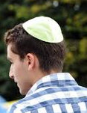
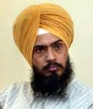
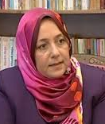
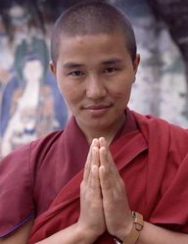
34. State which religions are represented by the following photographs:

___________________ ____________________ ____________________ ____________________ __________________
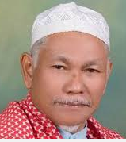
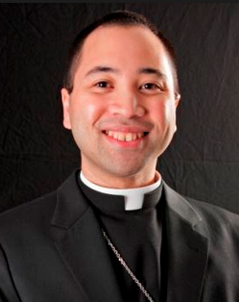
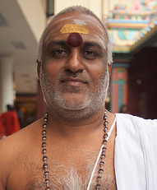
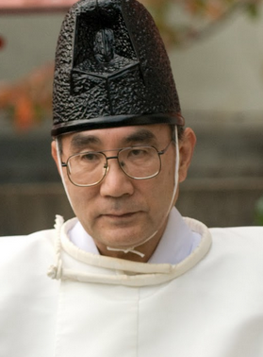
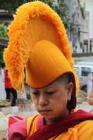

_____________________________ ______________________________ ______________________________ ______________________________ ___________________________

35. In the spaces provided below, list what you think are some of the false impressions people have about Muslims, which you think journalists have a role to play in correcting:
A.

B.

C.

D.

36. List what you think are some of the false impressions people have about Christians, which you think journalists have a role to play in correcting:

A.

B.

C.

D.

37. List what you think are some of the false impressions people have about Buddhists, which you think journalists have a role to play in correcting:

A.

B.

C.

D.

